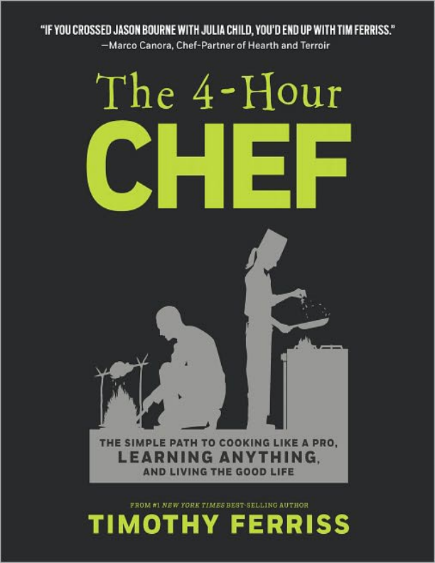
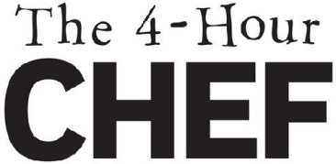
MUAY THAI—THE ART OF 8 LIMBS
MUAY TIM—THE ART OF 8 TOOLS
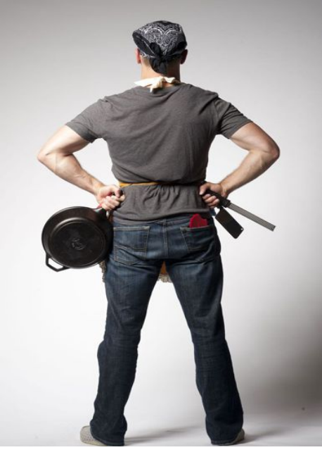
PUBLISHER’S DISCLAIMER
The material in this book is for informational purposes only. Since each individual situation is unique, you should use proper discretion, in consultation with a health-care practitioner, before undertaking the diet and exercise techniques described in this book. The author and publisher expressly disclaim responsibility for any adverse effects that may result from the use or application of the information contained in this book.
NOTICE ON FOOD HANDLING
This book is about cooking; it’s not a food processing and handling manual. I strongly encourage you to read and follow the established safe food processing and handling guidelines available through the USDA, FDA, and Department of Health and Human Services, including:
foodsafety.gov
fsis.usda.gov
fda.gov/food/foodsafety
NOTICE ON INTERNET RESOURCES
My full curriculum is within the covers of this book. For those of you who want to “go beyond” in your research, I have provided links to Internet resources. My team and I have worked to check that these links are accurate and point to resources available when this book was released for publication. But Internet resources change frequently, and other confounding variables beyond my control intervene. So, for various reasons, the links may not direct you to the resource I had intended. In many cases, you will likely be able to use your favorite search engine to locate the correct link. Where links to a good resource are not working, and avid readers among you let me know, we will work to provide updated and corrected links in posts or pages at fourhourblog.com.
NOTICE ON HAND WASHING
When in doubt, wash your hands. Touched meat? Wash your hands. Rinsed spinach? Wash your hands. Saw a shooting star? Yep, wash your hands. Do it more than you think necessary.
Copyright © 2012 Timothy Ferriss
All rights reserved.
This edition published by special arrangement with Amazon Publishing.
No part of this book may be reproduced, or stored in a retrieval system, or transmitted in any form or by any means, electronic, mechanical, photocopying, recording, or otherwise, without express written permission of the publisher.
Published by Amazon Publishing
P.O. Box 400818
Las Vegas, NV 89140
ISBN-13: 978-0-547-88718-0
Photo, illustration, and text credits constitute an extension of this copyright page.
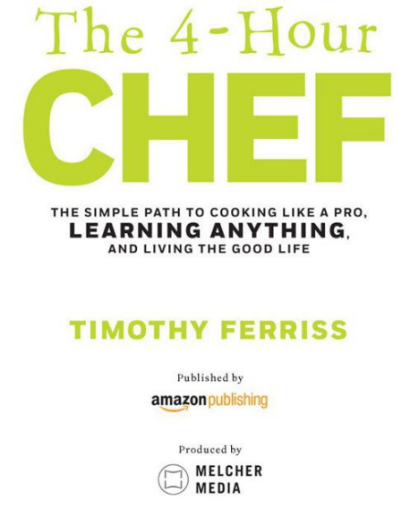
CONTENTS
RECIPE INDEX
INTRO
On the Shoulders of Giants
How to Use This Book
META-LEARNING
“Bill Gates Walks into a Bar…” The Power of Outliers
DECONSTRUCTION:
Exploring the Great Unknown
ASSIGNMENT:
Learning to “Taste”
SELECTION:
80/20 and Med
SEQUENCING:
The Magic of Proper Ordering
STAKES:
The Carrot and the Stickk
COMPRESSION:
Cheat Sheets for Anything
FREQUENCY:
Cramming Six Months of Culinary School into 48 Hours
ENCODING:
Making Slippery Ideas Stick
THE DOMESTIC
Rethinking Recipes
The 80/20 Pantry: All You Need
Top Gear: From Surgical Towels to Big Green Eggs Lesson Calendar
LESSON 01:
Osso “Buko”
LESSON 02:
Northeast African (or Middle Eastern) Scrambled Eggs Slow-Carb Wines: The Top 10 Lists
LESSON 03:
Coconut Cauliflower Curry Mash
LESSON 04:
Union Square Zucchini
The Vocabulary of Cutting
Introduction to Dim Mak
LESSON 05:
Harissa Crab Cakes
LESSON 06:
Bittman Chinese Chicken with Bok Choy
LESSON 07:
Arugula, Avocado, and Roma Salad
LESSON 08:
Sexy-Time Steak
In Search of the Perfect Cup of Coffee
LESSON 09:
9th Meal‒4-Person Dinner Party
LESSON 10:
Roasted Garlic and Gazpacho
LESSON 11:
Tim’s Top 4 Immersion Sauces: Pick One
LESSON 12:
Rock ’N’ Eel
LESSON 13:
Sous-Vide Chicken Breast
LESSON 14:
Seared Scallops
LESSON 15:
Chicken Higado Pâté
OPTIONAL LESSON 16:
“MLBJ”
LESSONS 17 & 17½:
The First Hosting Party, The Second Dinner Party
THE WILD
Top Gear Survival: Tarps, Traps, and Tactical Knives The Importance of Rabbits
The Manual Arts
The Rule of Threes
OPTIONAL LESSON 18:
How to Build a Debris Hut
OPTIONAL LESSON 19:
Making Drinkable Water
The Anti-Hunter’s First Hunt
The Gun
Top 10 U.S. Hunts According to Steve Rinella
LESSON 20:
Vietnamese Venison Burgers and Bagna Cauda
LESSON 21:
Sauerkraut
LESSON 22:
Sautéed Beef Heart
LESSON 23:
Feral Humans and the Golden Gate Buffet
LESSON 24:
Kevin’s “Best Pancakes of My Life” Acorn Pancakes
LESSON 25:
Muscle Cricket™ Protein Bars
The Odd Appeal of Street Quail
LESSON 26:
“Street Quail” Catch-and-Release
LESSON 27:
Hobo-Can “Hoboken” Cooking
Fishing: From Gill Nets to Yo-Yo Traps
LESSON 28:
Ceviche
LESSON 29:
Moules Marinière with Fennel
LESSON 30:
From Modern to Mallmann
LESSON 31:
How to Gut and Cook Tree Rat (Or Fish)
LESSON 32:
Sweet Potato Rescoldo
Nose to Tail, A to Z: Learning to Butcher
LESSON 33:
How to Butcher a Chicken
LESSON 34:
Lobstercide
The Kolkata (Calcutta) Market Incident
LESSON 35:
Clambake in a Garbage Can
THE SCIENTIST
A Trip to Seattle
The GNC Gourmet: The Fun of Multipurpose Ingredients Damage Control: Preventing Fat Gain When You Binge The Basics: Elementary, My Dear Watson…
The Science of Gels
Crunchy Bloody Mary
Arugula Spaghetti
Balsamic Vinaigrette Pearls
Olive Oil Gummy Bears
The Science of Spherification
Mojito Bubbles
The Science of Emulsification
Champagne Vinaigrette
The Science of Foams
Beet Foam
The Science of Solvents
Bacon-Infused Bourbon
The Science of Powders
Nutella Powder
The Science of Fermentation
Go-Carb Yeast Waffles (or Pancakes)
The Science of Dehydration
The Best Jerky in the World
The Science of Oxidation
How to Chop Wine: Hyperdecanting in 20 Seconds
The Science of Transglutaminase
Tuna and Yellowtail Checkerboard
The Science of the Maillard Reaction Rosemary Pistachio Cookies
The Science of Pressure Cooking
Caramelized Carrot Soup
The Science of Denaturation
Perfect Poached Eggs
Perfect Beef Short Ribs
The Science of Liquid Nitrogen
30-Second Cocoa-Goldshläger Ice Cream
The Triple Crown of Cheat Day: For the Piggies (in More Ways Than One)
#1 Welcome to the Jungle: The Vermonster
#2 The Turbacon: Sin Against Nature or Meat-Glue Masterpiece?
#3 The NYC Food Marathon: 26.2 Dishes in 26 Locations in 24 Hours
THE PROFESSIONAL
A Tale of Two Cities: New York
The Classics
Soffritto
Helicopter-Blade Pea Soup
Bear Fat (or Not) Fries
The “Hareiller ” Roast Chicken
Brown Butter Plantains
Bistro-Style Bavette Steak
French Omelet
A Tale of Two Cities: Chicago
Avant-Garde
How Grant Creates: 10 Principles
Serviceware
Paraffin Wax Bowls
Almond Za’atar Crackers with Tuna
Reversal
Cauliflower Crème Brûlèe
Technology
“Anti-Griddle ” Peppermint Chocolate Pops
“Bouncing” Flavors
Oyster + Kiwi
Rare Ingredients
Takashi Inoue’s “Tongue Experience ”
Form Mimicking
Bacon Roses
Edible Dirt Centerpiece
Texture Manipulation: Coconut Meal Dandelion “Coffee ” with Coconut Milk (Aperitif) Crisp-Baked Sesame-Coconut Chicken (Entrée) Coconut Paleo Pops (Dessert)
Profile Replication
Peking Duck Wraps
Themes
National Themes: Brazilian Meal
Hearts of Palm Salad (Appetizer)
Caipiroska Cocktail (Drink)
Feijoada (Entrée)
Ingredient Themes: Sage & Paprika Meal Kokkari Prawns (Entrée)
The Medicine Man (Digestif)
Sage Gelato (Dessert)
Aroma
Cigar-Infused Tequila Hot Chocolate
Dragonforce Chaconne
Carpe a l’Ancienne
Closing Thoughts—On More Perfect Days
APPENDIX
More Cooking Like a Pro
The Bite-Size World: 193 Recipes, 193 Countries
The Chef Genealogical Charts: An Unofficial Who’s Who (And Who Taught Whom)
Turning Pro Without Culinary School—The Full Training Program
More Learning Anything
How to Shoot a 3-Pointer Within 48 Hours
Guns?!? OMFG, ROFL, MPICIMFP, WTF?!?
Bicycleshop and the $10,000 Challenge: Memorizing a Deck of Cards in 43 Seconds
Nine Must-Know Knots
Building a Fire with a Bow Drill
More Living the Good Life
How to Become a VIP (and Other Tips)
Yelp’s 100 Best Restaurants in the U.S.A.
The Culinary Maps
Acknowledgments
Credits
Conversion Chart Scorecard
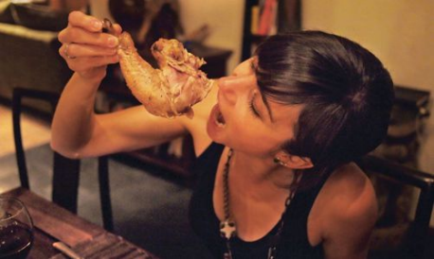
Dedication
For my parents, who taught a little hellion that marching to a different drummer was a good thing. I love you both and owe you everything. Mom, sorry about all the ridiculous
diets and experiments.
For Mark Twain, who had a great mustache and put it best: “Whenever you find yourself on the side of the majority, it’s time to pause and reflect.”
For leekspin.com, the most ridiculous site on the web. You helped me finish this book.
And for those who defend sustainable agriculture and promote truly good food. Ten percent of all author royalties are donated to rock-star nonprofits, such as American Farmland Trust (farmland.org) and the Careers through Culinary Arts Program (ccapinc.org).
6 REASONS TO READ THIS BOOK, EVEN IF YOU HATE COOKING (AS I DID)
The 4-Hour Chef (4HC) isn’t a cookbook, per se, though it might look like one. Just as Zen and the Art of Motorcycle Maintenance isn’t about changing oil, this book isn’t quite what it appears.
Even if you hate cooking, here are six reasons you should read at least the first few chapters of this book:
#1
YOU WILL LEARN HOW TO BECOME WORLD CLASS IN ANY SKILL IN RECORD TIME.
Whether you want to learn how to speak a new language in three months, how to shoot a three-pointer in one weekend, or how to memorize a deck of cards in less than a minute, the true “recipe” of this book is exactly that: a process for acquiring any skill. The vehicle I chose is cooking. Yes, I’ll teach you all the most flexible techniques of culinary school using 14 strategically chosen meals, all with four or fewer ingredients, and all taking 5–20 minutes to prepare (literally, The 4-Hour Chef). But I wrote this book to make you a master student of all things.
#2
EATING (AND LIFE) WILL BECOME HIGH-
DEFINITION.
In China, a common greeting is “Chi le, mei you?” or “Have you eaten?” This is the universal check-in. So I pose the question to you: have you really eaten? I now realize that before writing 4HC, I hadn’t. Back then, food was either good or bad, hot or cold, spicy or not. Now, it’s a million colors, and I can pick out the subtleties: the cilantro or tarragon, the umami savoriness, or the lack of vinegar. It’s like going from a 7" black-and-white TV to HD. Before 4HC, much of my life was in black and white. As you’ll see, the awareness we build in the kitchen and in related adventures will affect everything. Life itself becomes high-definition.
#3
YOU WILL GET INTO THE BEST SHAPE OF YOUR LIFE.
The dishes you’ll learn, apart from desserts for “cheat day,” are all compliant with the Slow-Carb Diet®, which has become a global phenomenon. Fat loss of 20 pounds in the first month is not uncommon. If you follow this book, you won’t have to think of following a diet, since it’s built in. If you ever decide to follow another diet, you’ll be twice as effective, because you’ll understand how to manipulate and maximize food.
#4
IT DOESN’T TAKE MUCH TO BECOME IMPRESSIVE.
In the first 24 hours, I’ll take you from burning scrambled eggs to osso buco, one of the most expensive menu items in the world. If 28% of Americans can’t cook at all,‡ and if another third are on some variation of mac and cheese, having even one seemingly difficult meal up your sleeve puts you in rare company. Make that two bulletproof meals and you can host impressive dinner parties for the rest of your life.
#5
COOKING IS THE MATING ADVANTAGE.
If you’re looking to dramatically improve your sex life, or to catch and keep “the one,” cooking is the force multiplier. Food has a crucial role in well-planned seduction for both sexes, whether in long-term relationships (“MLBJ”) or on first dates (Sexy-Time Steak). For real romantic superpowers, learn how to teach the skill of tasting (Learning to “Taste”).
#6
BECAUSE IT’S FUN.
The “practical” fails more than we’d like to admit. I’ll take breaks in this book as often as necessary to keep you amused. Food marathons? Check (The NYC Food Marathon). Hysterical kitchen lore anecdotes? Tons. Eating 14,000 calories in 20 minutes (The Vermonster)? Why not?
This isn’t a textbook. Think of it as a choose-your-own-adventure book.
As Bruce Lee said, “Adapt what is useful, reject what is useless, and add what is specifically your own.”
THE EDUCATION OF
A CULINARY IDIOT
1979, AGE TWO
I eat my first handful of crickets à la front yard. Life is good.
DECEMBER 1980
I stop eating crickets, to my mother’s delight. Now I’m tall enough to chomp on Christmas ornaments.
1989
As a rat-tailed townie in East Hampton, New York, I start working part-time in restaurants. The small collection of Long Island towns known as the Hamptons doubles as a playground for the rich and famous, while also serving as the hometown for landscapers, fishermen, and alcoholics who loathe the rich and famous. As a busboy, I worked at some of the highest-volume (The Lobster Roll) and highest-priced (Maidstone Arms) restaurants. For every Billy Joel, who smiled and tipped $20 for coffee, there were 20 wannabes in polo shirts with popped collars asking, “Do you know who I am?” I learned to hate restaurants and, by extension, cooking.
1999
While on the no-carb Cyclical Ketogenic Diet (CKD), I develop an insatiable desire for anything crunchy and start experimenting with low-glycemic baking. Pacing up and down the aisles at Safeway, I’m unable to find baking powder and conclude it must be the same as baking soda, which I grab. The chocolate-and-macadamia-nut cookies come out looking incredible, just in time for my friends to return from work. As manimals do, they each eat three cookies in seconds, promptly followed by power chucking on the lawn.
2000
To avoid starvation, I buy my first microwave.
2001
Subsisting on microwavable Lean Cuisines, I start watching the Food Network for 1–2 hours a night to decompress from my start-up. Half asleep one evening, I overhear Bobby Flay say, “Take risks and you’ll get the payoffs. Learn from your mistakes until you succeed. It’s that simple.” I type this up and put it on my desk for moral support during moments of self-doubt. There would be many.
2007
The 4-Hour Workweek is published after being turned down by 26 publishers. I’m still enjoying the Food Network six years later, and I still haven’t made a single dish.
2008
I become YouTube-famous for microwaving egg whites in plastic containers, which earns me the scorn of foodies worldwide. My follow-up act is a how-to video on “how to peel eggs without peeling them,” which gets more than 4 million views. Being too lazy to cook is apparently popular.
JANUARY 2010
My friend Jesse Jacobs wants to catch up on business and insists we cook dinner at my place. I respond that he’ll cook and I’ll handle wine. Unbeknownst to me, Jesse was a sous-chef (second in command) at a top restaurant in a former life. He insists on walking me through the meal. Pointing at a large Le Creuset pot he brought, he begins:
“Put those chicken pieces in the pot.” Check.
“Put in the veggies and potatoes. No need to cut them.” Ten seconds later, check.
“Pour in some olive oil and salt and pepper, and mix everything around with your hands to coat it. You don’t need to measure anything.” Ten seconds later, check.
“Now, put them in the oven.” Check.
“We’re done.”
I can’t believe it. “That’s it?” I ask, incredulous.
“Let’s catch up for two hours and drink some wine,” he says. It’s one of the most delicious meals I’ve had in years. Inspired, I decide to give cooking another chance.
JUNE 2010
My enthusiasm dies a quiet death. Overwhelmed by contradictory advice, poorly organized cookbooks, and unhelpful instructions (e.g., “Cook until done”), I throw in the towel yet again.
APRIL 2011
I meet my girlfriend, Natasha, who learned how to cook by imitating her grandmother. She didn’t do this as a child, but when she was in her mid-20s. She decides to teach me how:
“Smell this. Now smell this. Do they go together?”
“No. Gross.”
“OK, now smell this and this. Do they go together?”
“Yep.”
“Great. That’s cooking.”
Great sex ensues, and I decide I’ve been unfair to cooking. Groundhog Day.
AUGUST 2011
I commit to writing a book on learning, using cooking as the vehicle. Fun! My girlfriend can help!
SEPTEMBER 2011
Over the course of one week, I ask my girlfriend, “Is this basil?” 20 times. I want to punch myself in the face 20 times. Crisis of meaning. Revisit Bobby Flay quote.
OCTOBER 2011
After four weeks of nervous breakdowns and practically zero progress, I land in Chicago. Two days later, I replicate a two Michelin-star entrée (sea bass, Ibérico ham, watercress, butter, and olive oil) in my hotel bathroom sink with next to nothing: scalding-hot tap water, Ziploc bags, and a cheap Polder thermometer. It’s ready 20 minutes later and finished with a gorgeous crust, courtesy of the iron in the closet. I had learned the technique by watching a chef’s eight-year-old son. All is not lost.
NOVEMBER 2011
I hit the inflection point. Sitting at the Polaris Grill in Bellevue, Washington, I am suddenly able to see food in HD—as if someone had handed me prescription glasses and corrected lifelong blurred vision. All the random pieces come together; I can clearly “see” pairing through taste and smell (e.g., orange and fennel), I can tell if the steak is 100% grass-fed or grain-finished by the waxiness on the palate, I correctly guess the origins of the Dungeness crab, wine, and oysters (three types), and the cooking methods for the scallops, pork chops, and more. The waiter asks me if I’m a chef (answer: no), and the executive chef comes out to introduce himself. It is otherworldly.
NOVEMBER 24, 2011
I cook Thanksgiving dinner for four people. Graduation day. For a lifelong noncook, I feel on top of the world.
JANUARY 2012
I start eating crickets again, this time roasted. I’ve rediscovered the wonder of food…and the childlike curiosity I thought I’d lost.
ON THE SHOULDERS OF GIANTS
I am not an expert, nor am I a master chef.
I’m just the guide and explorer. If you find anything amazing in this book, it’s thanks to the brilliant minds who acted as resources, critics, contributors, proofreaders, and references. If you find anything ridiculous in this book, it’s because I didn’t heed their advice.
Though indebted to hundreds of people, I wish to thank a few of them up front, here listed in alphabetical order (see more in the Acknowledgments):
Chef Grant Achatz
Steve Alcairo
David Amick
Chef Tim Anderson
Marc Andreessen
Corey Arnold
Chef Blake Avery
Chef Ryan Baker
Marcie Barnes
Dr. John Berardi
Patrick Bertoletti
Mark Bittman
Chef Heston Blumenthal
Chad Bourdon
Daniel Burka
Chef Marco Canora
Phil Caravaggio
Chef Mehdi Chellaoui
Jules Clancy
Ed Cooke
Chef Chris Cosentino
Chef Erik Cosselmon
Erik “The Red” Denmark Chef Matthew Dolan
Chef Andrew Dornenburg Michael Ellsberg
Kevin “Feral Kevin” Feinstein Chef Mark Garcia
Brad Gerlach
Paul Grieco
Alan Grogono
Jude H.
Cliff Hodges
Ryan Holiday
Kirsten Incorvaia
Jesse Jacobs
Sarah Jay
Chef Samuel Kass
kitchit.com
Chef Dan Kluger
Nick Kokonas
Matt Krisiloff
Terry Laughlin
Karen Leibowitz
Martin Lindsay
Doug McAfee
Christopher Miller
Molecule-R
Elissa Molino
Harley Morenstein
Stephen Morrissey
Nathan Myhrvold
Chef Anthony Myint
Ayako N.
Natasha
Babak Nivi
Chef Sisha Ortúzar
Karen Page
Marcia Pelchat, PhD Chef Georgia Pellegrini Darya Pino
Jeff Potter
Kevin Reeve
Tracy Reifkind
Steven Rinella
John “Roman” Romaniello Kevin Rose
Barry Ross
Mike Roussell
Blake Royer
Anthony Rudolf III
Ian Scalzo
Chef Craig Schoettler Maneesh Sethi
Chef James Simpkins Naveen Sinha
Chef Joshua Skenes Bonnie Slotnick
Chef Damon Stainbrook Leslie Stein, PhD
Neil Strauss
Dean Sylvester
Tinywino
Rick Torbett
Gary Vay-ner-chuk
“Victor”
Josh Viertel
Robb Wolf
Chef Chris Young
Jeffrey Zurofsky
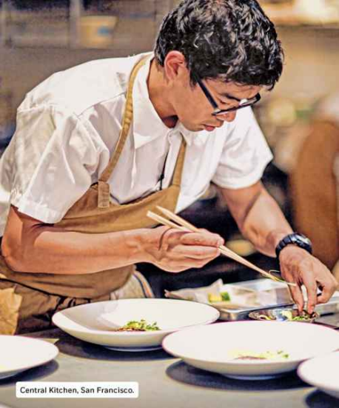
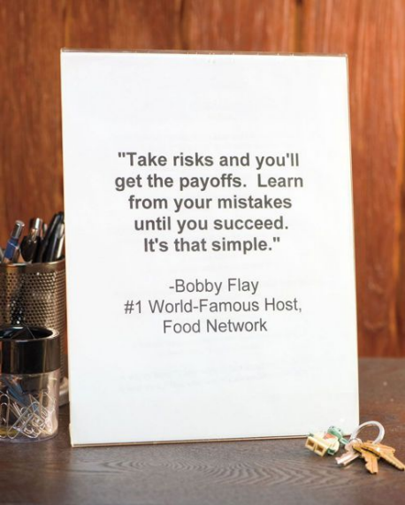The quote I’ve had on my desk since 2001.
HOW TO USE THIS BOOK:
CONFESSIONS, PROMISES, AND GETTING TO 20 MILLION
12 NOON, RIVERPARK RESTAURANT AS A GUEST “Doesn’t it taste like acorns?”
It did. Mangalitsa acorn-finished woolly boar tasted just like acorns. I was chewing on fall, clear as crystal, in a sliver of cured ham.
The clouds parted, and our plates were bathed in summer sunshine. Resting my elbows on the teak table, I looked out over the East River. Sunday brunch at 29th and First was off to a picturesque start.
Drinking albariño white wine with me were two friends: Josh Viertel, then president of Slow Food USA, and serial restaurateur “Z,”¹ whom I’d helped kick caffeine withdrawal the week before. I’d given him an l-tyrosine cocktail and, in exchange, he and Josh were teaching me the inside baseball of the food world.
“Check out the Bocuse d’Or—it’s the Olympics of cooking.” “If you want a really funny story, you should include how Thomas Keller, as an expert witness in a trial, analyzed a fried egg as evidence.”
“Visit Craft sometime. Leather covers the walls for acoustics. It distributes all the noise to the front and back corners, where the bathrooms—not diners—are.”
“Did you know sauté actually comes from the French ‘to jump’? To train the proper technique, you can put dried kidney beans in a skillet and mimic this motion while kneeling on a carpet.…” Demos ensued.
It was all new. I had never successfully cooked before, and that’s why I was there—to learn.
4 P.M., BACK OF HOUSE AS A TRAINEE
“Is this clean?” I asked.
“No. See this dirt, all over the stems? That’s not clean. Use a bowl instead of holding it under the faucet. Rinse three times.” “Thank you. Sorry about that,” I said with a sigh. I didn’t know how to rinse basil, let alone distinguish it from the two herbs next to it. I was trailing a prep cook, whose job is to prepare the basics— chopped onions, sorted microgreens, etc.—before dinner, when the line cooks assemble and plate everything for guests. She’d been told to give me something idiotproof.
“How’s the micro-basil coming?” she asked over her shoulder. I wasn’t one-tenth through the container I was supposed to sort. I simply couldn’t combine accuracy and speed. Now I was more than an inconvenience; I was jamming up her station.
After 30 minutes of fumbling, I was relieved of duty. It would be observation only for the rest of the night. As a spectator, I jotted down dozens of finer points I’d somehow missed the first 10 times through.
Why couldn’t I get it right?
At 6 p.m. I hung up my chef’s whites, looking like Eeyore from Winnie-the-Pooh. I had failed.
The team at Riverpark had been awesome, unbelievably forgiving, and, to my eyes, superhuman. Once dinner got rolling, I noticed that the line cooks’ forearms looked like they’d been dragged through hot coals and barbed wire.
Sixty minutes into the dinner rush, when I was convinced nothing could move faster, the chef de cuisine announced, “Look happy, boys. We have 42 open menus!” That meant 42 people were looking at menus at the same time, which meant 42 orders would hit two line cooks at the same time. Chino, one of the two, kicked into high gear, moving fire and food for dozens of orders like Doctor Octopus on fast-forward.
They were completely unfazed. Another day at the office. Me? Decimated by washing a handful of leaves.
When I walked outside and back into civilian life, I hugged a new bible under one arm: The Silver Spoon, the best-selling Italian cookbook of the last 50 years. To me, it was like holding the Necronomicon. Sisha, the Chilean chef-partner, had given it to me when I first toured the kitchen earlier that day. It was his copy, and he’d insisted I take it after I commented on its beauty. Now, I felt guilty for taking it.
I edged alongside Riverpark’s outdoor farm, keeping out of frame of a car commercial being filmed in the traffic circle 30 feet away. As I jogged past an extra to catch a cab, he looked at the bundle under my arm and asked with a smile,“Future chef?”
I looked back and returned the smile as best I could. “Yeah.”
DIGITAL DEPRESSION AND THE PUZZLE OF COOKING
In 2011, a slow-growing malaise came to a head.
It hit me like acid reflux, a dull ache every time I closed my laptop with nothing to show for my effort besides invisible bits and bytes. One reflective weekend, I decided that I wanted to try woodworking: to make something. I needed to use my hands to create something. Swinging a tennis racket or lifting weights, as physical as they were, didn’t cut it.
Sadly, life got in the way. The Oakland woodworking studio was too far away, I couldn’t commit to a fixed time each week, I didn’t have space for what I’d make—the usual list of I’m-busy-being-busy excuses.
Then, one evening, I took my girlfriend to the mecca of Northern California cooking, the world-famous Chez Panisse in Berkeley. Despite a decade in the Bay Area, I’d never been, partially because I still behaved like a cash-poor recent grad (remedied in this case by a gift certificate). Shelves of The Art of Simple Food by Chez Panisse founder Alice Waters lined the wall behind the bar. I skimmed a red spined copy while we sipped wine and waited to be seated. I ended up engrossed and, much to the chagrin of my girl, took notes while we ate. As I half-watched the bustle in the open kitchen, and assured the server that I’d buy the book, I underlined two passages in particular:
“When you have the best and tastiest ingredients, you can cook very simply and the food will be extraordinary because it tastes like what it is.” And: “Good cooking is no mystery. You don’t need years of culinary training, or rare and costly foodstuffs, or an encyclopedic knowledge of world cuisines. You need only your own five senses.”
By the time the bill came, I was practically bouncing in my seat. “Babe, I think I could actually do this!”
Cooking would become my tool for reclaiming the physical world. It was time to use my opposable thumbs for something besides the space bar.
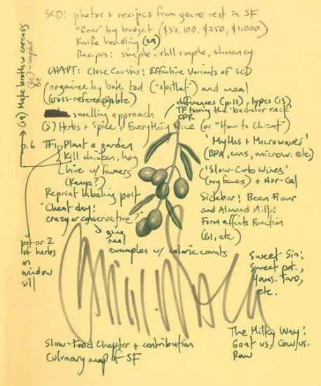My very first notes in The Art of Simple Food. The beginning.
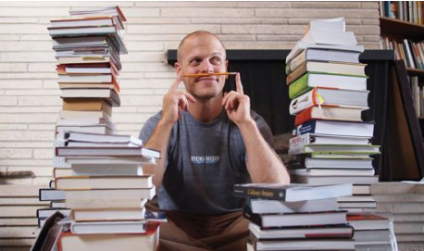
The starting point: hundreds of books, filtered by overlaying survey results, average Amazon reviews, and Nielsen Bookscan sales numbers.
Cooking wasn’t the first skill I’d tackled. In fact, I’m somewhat obsessed with accumulating strange credentials, ranging from a Guinness World Record in tango to a gold medal at the 1999 Chinese national kickboxing championships.
Given this, why had cooking kicked my ass so many times?
There’s an overabundance of information. No other subject matter I’ve encountered comes close. It’s a full-time job just to find the best place to start.
Cookbooks are often formatted for the writers, I discovered, not for the readers. A logical grouping for the writer is rarely a logical progression for the student. Who’s going to cook six chicken dishes in a row?
Cooking practice can be expensive and impractical. If you have the time, you can practice your tennis serve a thousand times a
day for a few dollars. Making a thousand omelets a day? That’s a different story.
So, what to do?
WHY YOU’LL SUCCEED—TWO PRINCIPLES I eventually learned to cook by focusing on two principles. Both of them apply to all learning and will be your constant companions throughout this book: failure points and the margin of safety.
FAILURE POINTS—THE POWER OF PRACTICAL PESSIMISM I don’t care why people pick up cookbooks. I’m much more interested in why they put them down.
The hypothesis: if I can address the primary, but often ignored, tripping points, I should be able to increase the number of people who eventually become master chefs. To develop a list of failure points—the reasons people put cookbooks down—I polled more than 100,000 of my fans on Facebook (64% male, 36% female) and looked for patterns. Here are a few:
Too many ingredients (and therefore too much shopping and prep).
Intimidating knife skills, introduced too early in cookbooks. Too many tools, pots, and pans, which are expensive and require too much cleanup.
Food spoilage.
Different dishes finishing at different times, leading to cold food, undercooked food, burned food, etc.
Dishes that require constant tending, stirring, and watching.
Saying I can create more master chefs doesn’t mean I’m a master chef, even if I’ve improved 100-fold (which I have).
Nor does it mean that this book alone will make you a master chef. It simply means that no master chef exists who hasn’t overcome the above problem areas, so addressing them should be a novice cookbook’s primary goal, not an afterthought.
This book aims to systematically overcome all of the above failure points, step-by-step.
THE MARGIN OF SAFETY—IF WARREN BUFFETT DESIGNED MENUS
Most cookbooks ignore how unreliable recipes can be. As scientist Nathan Myhrvold points out, even if you follow the exact same recipe using identical equipment and ingredients, humidity and altitude alone can create totally different outcomes. If a cookbook author is testing a recipe in Tahoe during the winter and you try to replicate it in San Diego in July heat, you might fail, even though you follow it perfectly. Rather than hope your environment is the same as mine, I looked for bulletproof recipes.
This is where the margin of safety applies.
Warren Buffett is the most successful investor of the 20th century and a self-described “value investor.” He aims to buy stocks at a discount (below intrinsic value) so that even with a worst-case scenario, he can do well. This discount is referred to as the “margin of safety,” and it’s the bedrock principle of some of the brightest minds in the investing world (e.g., Joel Greenblatt). It doesn’t guarantee a good investment, but it allows room for error.²
In the world of cooking, I’ll apply the margin of safety as follows: how badly can you mangle the recipe and still get something incredible? In real estate, the adage is, “You make your profit when you buy the property, not when you sell it.” In cooking, it could be, “You guarantee a good meal by picking the recipes well, not by following recipes well.”
Early wins are critical for momentum, so we’ll guarantee them.
THE PROGRESSION—DOM, WILD, SCI, PRO There are five sections in this book. After META-LEARNING, the progression is color-coded for difficulty, just like jujitsu: blue, purple, brown, and black.
From the science of el Bulli, the famed Spanish restaurant that was harder to get into than Harvard,³ to the fish markets of Kolkata to the backcountry of South Carolina, no stone was left unturned in search of powerful simplicity.
Below we’ll examine what our journey together will look like.
The Menu
L’ANTIPASTO
META-LEARNING
(META)
This is where I introduce every important principle I’ve discovered about accelerating learning.
It starts with smart drug self-experimentation at Princeton (inhaling hormones, anyone?), progresses to language learning, and branches off into everything imaginable: sports, memorizing numbers, “learning” smells, deconstructing food, even cramming six months of culinary school into 48 hours.
If you’re only interested in cooking, you can skip this section, but I highly suggest you give it a read at some point. It is the backbone of this book.
IL PRIMO
THE DOMESTIC
(DOM)
DOM is where we learn the building blocks of cooking. These are the ABCs that can take you from the simplest words to Shakespeare.
The goal of this section is ambitious: to deliver all the fundamental building blocks of culinary school in four hours of total prep time: 14 core dishes x 5–20 minutes. This is the literal portion of The 4-Hour Chef. Here, we also begin to answer the question that Sherry Yard, the executive pastry chef of Spago in Beverly Hills, put to me when I explained the premise of the book: “How do you cut time without cutting corners?”
The secret is in sequencing.
If you stop reading here, you will know “how to cook” for all intents and purposes and will earn back the price of this book manyfold.
IL SECONDO
THE WILD
(WILD)
WILD is where you will become not only good with your hands, but also self-sufficient in your own hands. If you’ve ever wondered about urban foraging, fermentation, hunting, or pigeons as food, this will probably be your favorite section.
IL CONTORNO
THE SCIENTIST
(SCI)
If WILD is the die-hard pragmatist, SCI is the mad scientist and modernist painter wrapped into one.
Rather than preparing you for spartan minimalism, this section is about rediscovering whimsy and wonder, two ingredients sorely lacking past childhood.
IL DOLCE
THE PROFESSIONAL
(PRO)
Swaraj, a term usually associated with Mahatma Gandhi, can be translated as “self-rule.” Think of it as charting your own path.
In PRO, we’ll look at how the best in the world become the best in the world, and how you can evolve far beyond this book. There’s much more to cooking besides food. Take Chef Grant Achatz “plating” your table, which is covered in gray latex, by dropping and shattering a dark-chocolate piñata full of assorted desserts. It’s texture, theater, and so much more, all wrapped into one.
We’ll finish up with tools for perfecting your own creative powerhouse.
THE MICRO GOAL—ON BECOMING A “CHEF” Julia Child wasn’t always Julia Child. In fact, she could barely boil an egg when she got married.
Late in her career, she became a chef—and changed how the English-speaking world viewed cooking.
In restaurants, the distinction between cook and chef is important: someone who can cook is a cook, whereas someone who can create a menu and run a kitchen is a chef. Calling yourself the latter when you’re the former, as many TV hosts do, is a no-no. In some circles, the cook is a technician, however good, and the chef is the conductor. The former is the bricklayer, the latter the architect of the cathedral.
In The 4-Hour Chef, I use chef in the most literal sense, like the Spanish jefe. Derived from the Latin term for “head,” it signifies boss or leader. This book aims to make you self-reliant, whether in the kitchen or in life: to wrestle control from chaos, to feel like a director instead of an actor, and perhaps to create something bigger than yourself.
In their wonderful book Culinary Artistry, Andrew Dornenburg and Karen Page provide a table with three hypothetical categories of chefs.
My goal is to move you from the far left to the right, and the customer quotes will be your own. The most important part of all is that you finish your meals with the bottom-right sentiment. Even if you end your journey at burgers—damn fine burgers, mind you—life can and should be wonderful.
We’ll use training in the kitchen as training for everything outside of the kitchen.
THREE TYPES OF CHEFS—THE PROGRESSION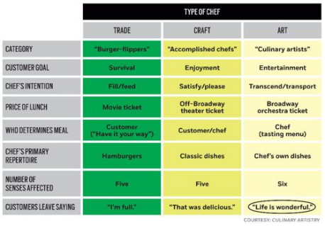
THE MACRO GOAL—20 MILLION PEOPLE I’d never had coffee-cup envy before. But this was one hell of a coffee cup:
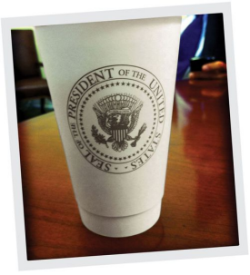
“Can I get one of those?” I asked.
“Probably not,” Sam replied.
Well, it was worth a try.
Sam Kass honed his culinary skills at Avec restaurant in Chicago. Then he became a private chef and started cooking for an up-and coming senator named Barack Obama. Now, as assistant White House chef and food initiative coordinator, Sam is one of the first family’s go-to experts in all things culinary. This spans from national food policy to replacing pesticides in their backyard with crab meal and ladybugs.
When Sam and I met in Washington, D.C., I explained my background in publishing and tech, mentioned the acquisition of this book by Amazon Publishing, and politely asked his advice:
“I have a platform to reach millions of people, and I don’t want to screw up this opportunity. I might not get it again. How should I be thinking about the bigger picture of food?”
His answers paralleled what I’d read and heard from Mark Bittman, the great New York Times Magazine food writer: in effect, that we are at a deciding fork in the road, and the next 10 years (perhaps less) will decide the future of food production in the United States.
Here are a few of my notes, from multiple sources:
In the U.S., the last generation of career farmers is retiring. Specifically, more than 50% are set to retire in the next 10 years. Their farmland will be up for grabs. Will it go to an industrial agro-corp like Monsanto, and therefore most likely lead to monocrops (wheat, corn, soy, etc.) that decimate ecosystems? Will it be strip malls? Or might it become a collection of smaller food producers? The last option is the only one that’s environmentally sustainable. It’s also the tastiest. As Michael Pollan would say: how you vote three times a day (with the meals you eat) will determine the outcome.
Going small can amount to big economic stimulus. Let’s look at the economic argument for shifting from a few huge producers to many smaller producers: by diversifying crops beyond corn and soybeans in just six agricultural states, the net economic gain would be $882 million in sales and 9,300 jobs, according to the Leopold Center for Sustainable Agriculture at Iowa State University.
Environmental impact? Converting the U.S.’s 160 million corn and soybean acres to organic production would sequester enough carbon to satisfy 73% of the Kyoto targets for CO² reduction in the U.S.
In other words, the fun you have in this book will do a lot of good beyond you and your family. In many ways, our eating behavior in the next few years will decide the future of the entire country.
The magic number and my target is 20 million people. It is the tipping point: 20 million people can create a supertrend. To dodge the submerged iceberg of industrial-scale food production and its side effects, to alter the course of this country and reinvigorate the economy, all I need to do is make you more interested in food. In total, we need to make 20 million people more aware of eating.
This will lead to changes, starting with breakfast. Then the snowball of consonant decisions takes care of the rest. Stranger things have happened.
LET US BEGIN WITH BEGINNER’S MIND
Mise en place, called meez in kitchen slang, means everything in its place. Commit this term to memory. It refers to your workplace. In this book, it also refers to your mind, your business, and your life.
One of Anthony Bourdain’s former chef colleagues had a habit of walking up to frazzled cooks in his kitchen, pressing his hand into their cutting boards, and lifting his palm to their faces. As he showed them the detritus embedded in his skin, he’d say, “You see this? That’s what the inside of your head looks like now.”
What does your mind look like?
We’ll find out, and we will make it orderly.
While in Kolkata, India, for this book, I stayed at the iconic Oberoi Grand. The concierge explained to me the hotel’s hiring philosophy: “You can’t bend mature bamboo. But if you get it as a young shoot, you can bend it, mold it. We hire them between the ages of 18 and 21 so we can mold them.” The concierge was one of only 15 double golden key (Clef d’Or) concierges in India, and he knew that sometimes having no experience is a huge advantage. Age doesn’t matter; an open mind does.
This book isn’t baptism by fire. It’s a series of small experiments, with the occasional off-color joke and Calvin and Hobbes cartoon to keep you interested. The only part I consider mandatory reading, DOMESTIC, is fewer than 150 pages! Skip around and have fun.
This book is not the truth, but it contains many truths as I’ve found them, and—even if they’re not your truths—the process I teach can help you find yours.
May all of your creations have just the right flavor, and may the joy of discovery be your guide.
Pura vida,
Tim Ferriss
San Francisco, California August 24, 2012
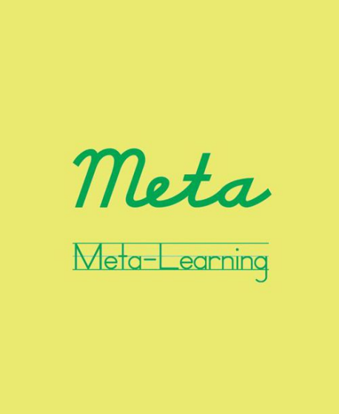
-
META is where you’ll learn to mimic the world’s fastest learners.
It is possible to become world-class in just about anything in six months or less. Armed with the right framework, you can seemingly perform miracles, whether with Spanish, swimming, or anything in between.
“BILL GATES WALKS INTO A BAR…”: THE POWER OF OUTLIERS
“A good teacher must know the rules; a good pupil, the exceptions.”
— MARTIN H. FISCHER, PHYSICIAN AND AUTHOR
Smart Design became one of the top industrial design firms in the world by being (you guessed it) smart.
With locations in New York, San Francisco, and Barcelona, Smart Design represents clients ranging from Burton Snowboards to Starbucks. The company has also been strategic partners with OXO International since 1989. That ubiquitous line of Good Grips kitchenware with the comfy black handles? The ones that cover an entire wall at Bed Bath & Beyond? They made ’em.
In the documentary Objectified, Dan Formosa, PhD, then with Smart Design’s research department, explained one of the first steps in its innovation process:
“We have clients come to us and say, ‘Here is our average customer.’ For instance, ‘Female, she is 34 years old, she has 2.3 kids,’ and we listen politely and say, ‘Well, that’s great, but we don’t care…about that person.’ What we really need to do, to design, is look at the extremes. The weakest, or the person with arthritis, or the athlete, or the strongest, the fastest person, because if we understand what the extremes are, the middle will take care of itself.”
In other words, the extremes inform the mean, but not vice versa. That “average user” can be deceptive or even meaningless, just as all averages¹ can be. Here’s a statistician joke for your next hot date:
Person A: What happens when Bill Gates walks into a bar of 55 people?
Person B: I don’t know. What?
Person A: The “average” net worth jumps to more than a billion dollars!²
Buahaha! Not exactly Chris Rock, but the joke makes an important point: sometimes it pays to model the outliers, not flatten them into averages. This isn’t limited to business.
Take, for instance, this seemingly average 132-lb girl who ended up anything but:
The girl next door…kind of.
Her picture was sent to me by Barry Ross, a sprint coach who creates world-record-breaking athletes, to illustrate an ab exercise called the torture twist. He nonchalantly added on the phone: “Oh,
and she dead-lifts more than 400 lbs for repetitions.” What?!? For those of you not familiar with the dead lift, take a look at the following sequence of Mark Bell lifting 485 lbs.
Even more impressive, she developed this otherworldly power the “wrong” way:
Rather than train the conventional full range of motion, she utilized only the weakest range of motion, lifting the bar to knee height and then lowering it.
Total muscular tension (actual weight lifting) was limited to five minutes per week.
This all makes our average-looking high-schooler extreme. But was she an exception?
In the outside world, absolutely. Even in track and field, she was a freak. Had she been thrown into a study with 40 randomly selected female sprinters, she would have been a ridiculous exception. “Must have been a measurement error!” Then the baby would get thrown out with the bathwater.
But WWWBS? That is: What Would Warren Buffett Say? I suspect the Oracle of Omaha would repeat what he said at Columbia
University in 1984 when mocking proponents of the efficient-market hypothesis.
First, he pointed out that, yes, value investors (devotees of Benjamin Graham and David Dodd) who consistently beat the market are outliers. Then he posed a question, which I’ve condensed:
What if there were a nationwide competition in coin flipping, 225 million flippers total [then the population of the USA], each flipping once per morning, and we found a select few [say, 215 people] who’d flipped 20 straight winning flips [flips where the result was guessed correctly] on 20 mornings?
He then continued (bolding is mine):
“Some business school professor will probably be rude enough to bring up the fact that if 225 million orangutans had engaged in a similar exercise, the results would be much the same—215 egotistical orangutans with 20 straight winning flips.
There are some important differences in the examples [of value investors] I am going to present. For one thing, if a) you had taken 225 million orangutans distributed roughly as the U.S. population is; if b) 215 winners were left after 20 days; and if c) you found that 40 came from a particular zoo in Omaha, you would be pretty sure you were on to something. So you would probably go out and ask the zookeeper about what he’s feeding them, whether they had special exercises, what books they read, and who knows what else. That is, if you found any really extraordinary concentrations of success, you might want to see if you could identify concentrations of unusual characteristics that might be causal factors.”‡
Our sprint coach, Barry Ross, has a most unusual zoo. In fact, he can engineer mutants at will.
His best female distance runner has deadlifted 415 lbs at a body weight of 132 lbs.
His youngest male lifter, 11 years old, has dead-lifted 225 lbs at a body weight of 108 lbs.
Our extreme high-schooler is the standard in his gym. This naturally led me to ask: could I, a nonelite runner and an average, possibly replicate her results? I tried, and…it worked flawlessly.
In less than 12 weeks, sans coach and following a printout from Barry, I went from a max dead lift of 300 lbs to more than 650 lbs.³
BEING THE BEST VS. BECOMING THE BEST As I write this, the two most-viewed freestyle swimming videos in the world are of:
1. Michael Phelps
2. Shinji Takeuchi
Phelps makes sense, but…who the hell is Shinji Takeuchi? Phelps learned to swim at the tender age of seven. Shinji learned to swim at the well-ripened age of 37. More interesting to me, Shinji learned to swim by doing practically the opposite of Phelps:
Shinji drives his lead arm forward, almost two feet beneath the water, rather than “grabbing” near the surface and pulling. Rather than focus on kicking, Shinji appears to eliminate it altogether. No paddleboard workouts to be found.
Shinji often trains freestyle stroke with closed fists, or by pointing his index finger forward and keeping the arms entirely underwater.
Phelps looks like he’s attached to an outboard motor. It’s a heroic output of horsepower. Shinji has been watched millions of times because he offers the flip side: effortless propulsion.
So who would you rather have as a teacher: Phelps or Shinji? Arthur Jones, founder of Nautilus, when asked how to gain muscular mass quickly, recommended the following (I paraphrase): approach the biggest bodybuilder at your gym, ideally a ripped 250– 300-lb professional, and politely ask him for detailed advice. Then do precisely the opposite. If the T-Rex–size meathead recommends 10 sets, do one set; if he recommends post-workout protein, consume pre-workout protein, etc.
Jones’s tongue-in-cheek parable was used to highlight one of the dangers of hero worship:
The top 1% often succeed despite how they train, not because of it. Superior genetics, or a luxurious full-time schedule, make up for a lot.
This is not to say that Phelps isn’t technical. Everything needs to be flawless to win 18 gold medals. It’s the people a few rungs down —the best you realistically have access to—whom you need to be wary of.
And then there is the second danger of hero worship: Career specialists can’t externalize what they’ve internalized. Second nature is hard to teach.
This is true across industries.
As Erik Cosselmon, executive chef at Kokkari, my favorite Greek restaurant in San Francisco, said to me amid my novice questioning: “The problem with me is I’ve always been a cook. I don’t remember ever wanting to be something else.”
Daniel Burka, a designer at Google and the cofounder of tech start-up Milk, echoes the sentiment: “I don’t think I’d be particularly good at teaching the basics of CSS [a language used for the look and formatting of web pages⁴]. Now I do 12 things at once and they all make sense. I can’t remember which of those was confusing when I was just starting out.”
These top 0.01%, who’ve spent a lifetime honing their craft, are invaluable in later stages, but they’re not ideal if you want to rocket off the ground floor. The Shinji Takeuchis, on the other hand—the rare anomalies who’ve gone from zero to the global top 5% in record time, despite mediocre raw materials—are worth their weight in gold.
I’ve spent the last 15 years finding the Shinjis of the world and trying to model them.
INHALING HORMONES: WHAT COULD GO WRONG?
My old friend desmopressin.
My interest in accelerating learning started at a biochemical level. In 1996, as a planned neuroscience major at Princeton University, I began experimenting with a panoply of smart drugs (nootropics) I’d imported to the U.S. under the FDA personal importation policy.⁵ After four weeks, I’d fine-tuned a routine for Mandarin Chinese character quizzes: 15 minutes prior to class, I would administer two hits of vaporized desmopressin in each nostril. Desmopressin is a synthetic version of vasopressin, a naturally occurring anti-diuretic and peptide hormone. As a nasal spray, it is often prescribed for children who bed-wet past a certain age. I was more interested in its off-label applications for short-term memory.
Putting theory into practice, it looked like this:
1. Two hits of desmopressin in each nostril.
2. Flip through characters in Chinese Primer: Character Text almost as quickly as I could turn the pages.
3. Score 100% on the quiz 5–10 minutes later.⁶
It was fantastically reliable.
But after a few months of testing Hydergine, oxiracetam, and combinations of dozens of other drugs, headaches set in and a thought occurred: perhaps snorting anti-diuretic hormones isn’t the best long-term strategy? My dorm bathroom had also started to resemble a meth lab, which was repelling girls.
So I shifted my obsession from molecules to process. Was it possible to develop a sequence, or a blueprint, that would allow one to learn anything faster? Any subject, any sport, anything at all?
I suspected so.
I’d glimpsed one piece of the puzzle four years earlier, in 1992.
MATERIAL BEATS METHOD
In 1992, I was 15 years old and had landed in Japan for my first extended trip abroad. I would be an exchange student at Seikei Gakuen high school for one year.
On the first day of classes, I reported to the faculty lounge in my required navy-blue uniform, looking like a West Point cadet. I nervously awaited my student chaperone, who would be taking me to my “home class,” the group of 40 or so students I’d be spending most of my time with. One of the faculty members noticed me sitting in the corner and approached:
“Ah, Timu-kun!” he said with a wave. Kun is like -san but used to address male inferiors.
“Kore wa…” This is… he said as he pointed at a mysterious piece of paper. I could barely manage greetings, so he hailed an English teacher to explain the document. The page, written entirely in characters I couldn’t read, detailed my daily schedule, as it turned out.
The English teacher translated: “Physics, mathematics, world history, kōbun—ah…traditional Japanese,” and on it went. Panic set in. I’d only had a few months of rudimentary Japanese prior to arrival, and my teachers in the U.S. had reassured me with: “Don’t worry, you’ll have plenty of Japanese classes!” Now irretrievably in Tokyo, I realized I was dealing with a major Lost in Translation screwup. “Japanese classes” hadn’t meant language classes. For the entire year ahead, I was to attend normal Japanese high school classes alongside 5,000 Japanese students prepping for university exams! This is when I pooped my Pampers. I proceeded to flounder horribly, just as I’d failed with Spanish in junior high. Sadly, it seemed I was simply “bad at languages.” Six months into my exchange, I was ready to go home.
Then Lady Luck smiled upon me. I stumbled upon a poster while looking for The Book of Five Rings in the Kinokuniya bookstore in Shinjuku.
This poster, which I still have on my wall 20 years later, contains all 1,945 of the jōyō kanji , the characters designated for

